**9.1 Glucose Transport**

|  |  |  |
| --- | --- | --- |
|  | **GLUT2** | **GLUT4** |
| **Important tissues** | Liver, pancreas | Adipose tissue, muscle |
| **Km** | High (~15mM) → the liver will pick up glucose in proportion to its concentration in the blood (first-order kinetics) → the low affinity of this transporter allows it to only shuttle glucose into the liver and pancreas when glucose levels are high (like after a meal) | Low (~5mM) → when a person has high blood sugar concentrations, these transporters will still permit only a constant rate of glucose influx because they will be saturated (zero-order kinetics) |
| **Saturated at normal glucose levels?** | No --- cannot be saturated under normal physiological conditions | Yes --- saturated when glucose levels are only slightly above 5mM |
| **Responsive to insulin?** | No (but serves as a glucose sensor to cause release of insulin in pancreatic β-cells) | Yes |

**9.2 Glycolysis\***

* Occurs in the **cytoplasm** of all cells, and does not require oxygen
* Yields 2 ATP per molecule of glucose

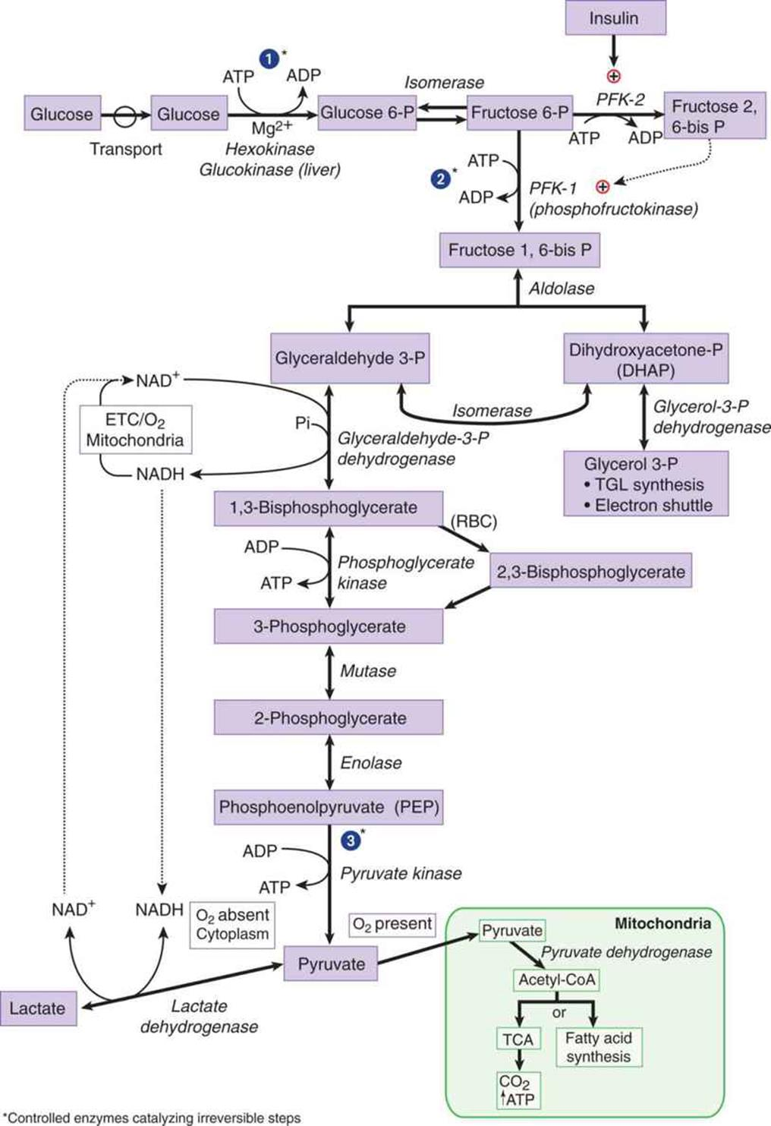

Important Enzymes of Glycolysis

1. Hexokinase and Glucokinase
   1. Glucose enters the cell by facilitated diffusion or active transport
   2. In either case, these kinases convert glucose to G6P
   3. Because GLUT transporters are specific for glucose (NOT phosphorylated glucose), the glucose gets “trapped” inside the cell and cannot leak out

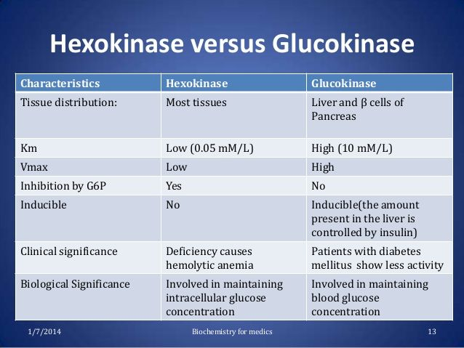

1. Phosphofructokinase-1 (PFK-1)
   1. Phosphorylates F6-P to F1,6-BP in the **rate limiting step of glycolysis**
   2. Activated by AMP and F2,6-BP
      1. The cell should turn on glycolysis when it needs energy (low glucose → high AMP)
   3. Inhibited by ATP and citrate
      1. The cell should turn off glycolysis when it has sufficient energy (ATP, or citrate from Citric Acid Cycle which implies the cell is producing sufficient energy)
2. Phosphofructokinase-2 (PFK-2)
   1. Produces F2,6-BP that activates PFK-1
   2. Activated by insulin and inhibited by glucagon
   3. Found mostly in the liver → by activating PFK-1, it allows these cells to override the inhibition caused by ATP → glycolysis can continue even when the cell is energetically satisfied
3. Glyceraldehyde-3-phosphate (G3P) dehydrogenase
   1. Produces NADH, which can feed into the ETC
4. 3-phosphoglycerate kinase and pyruvate kinase
   1. Both perform **substrate-level phosphorylation** (the only means of ATP generation in an anaerobic tissue), placing an inorganic phosphate (Pi) onto ADP to form ATP

Fermentation

* Occurs in the absence of oxygen
* Reduces pyruvate to lactate, and oxidizes NADH to NAD+ (this replenishes the oxidized coenzyme for G3P dehydrogenase for substrate-level phosphorylation of ATP)

Important Intermediates of Glycolysis

1. Dihydroxyacetone phosphate (DHAP)
   1. Used in hepatic and adipose tissue for triacylglycerol synthesis
   2. Can be isomerized to form G3P, which can then be converted to glycerol, the backbone of triacylglycerols
2. 1,3-Bisphosphoglycerate (1,3-BPG) and phosphoenolpyruvate (PEP)
   1. High energy intermediates used to generate ATP by substrate-level phosphorylation (the only ATP gained in anaerobic respiration)

Irreversible Enzymes

1. Glucokinase or hexokinase
2. PFK-1
3. Pyruvate kinase

Glycolysis in Erythrocytes

* RBCs do not have mitochondria → no oxidative phosphorylation → only substrate-level phosphorylation via anaerobic glycolysis → yields a net 2 ATP per molecule
* Mutase converts 1,3-BPG to 2,3-BPG → rightward shift in the oxygen dissociation curve → decreases hemoglobin’s affinity for oxygen → increases unloading of oxygen in tissues (but still allows 100% saturation in the lungs)

**9.3 Other Monosaccharides**

Galactose Metabolism

* Lactose (in milk) is hydrolyzed to galactose and glucose by lactase, which is a brush-border enzyme of the duodenum
* Trapped in the cell by **galactokinase**, and converted to **G1P** via **G1P-uridyltransferase** and an **epimerase**

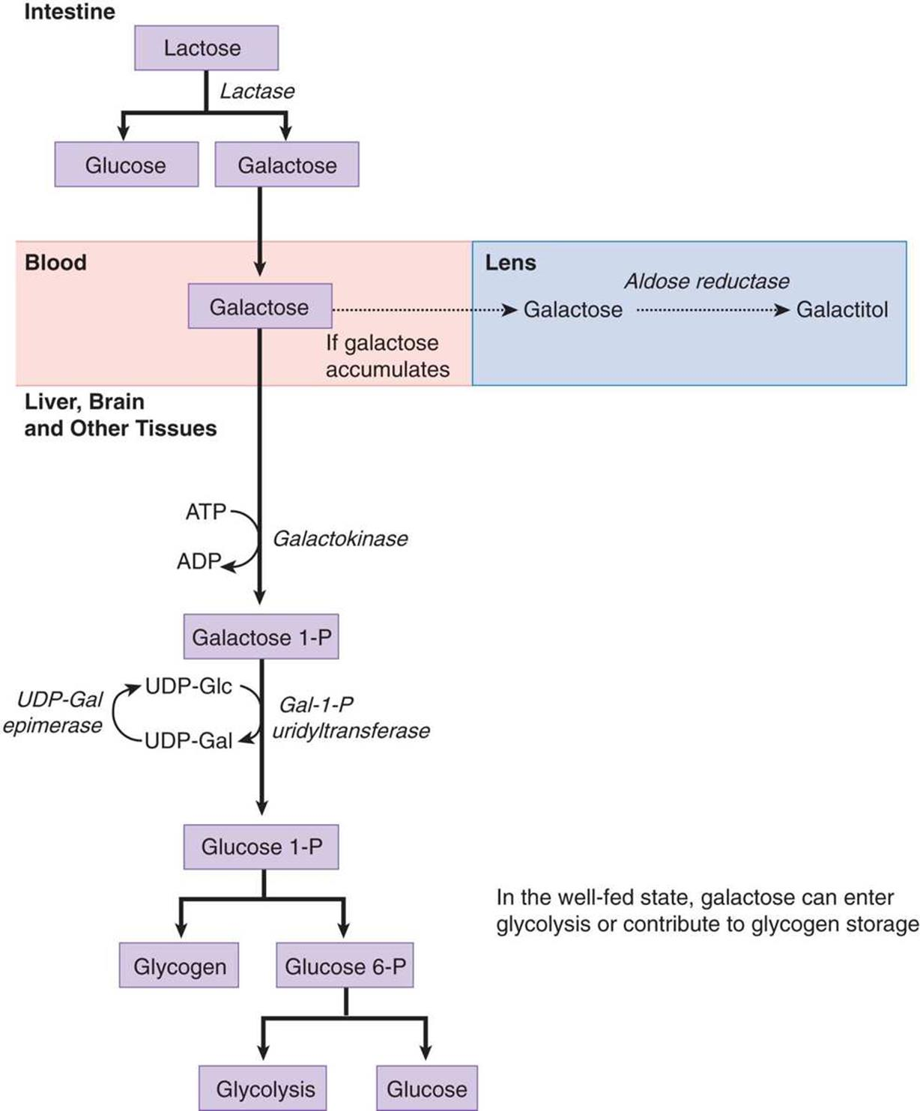

Fructose Metabolism

* Sucrose (in common table sugar) is hydrolyzed by the duodenal brush-border enzyme sucrase to form glucose and fructose (in honey and fruit)
* Trapped in the cell by **fructokinase**, and then cleaved by **aldolase B** to form **glyceraldehyde** and **DHAP**

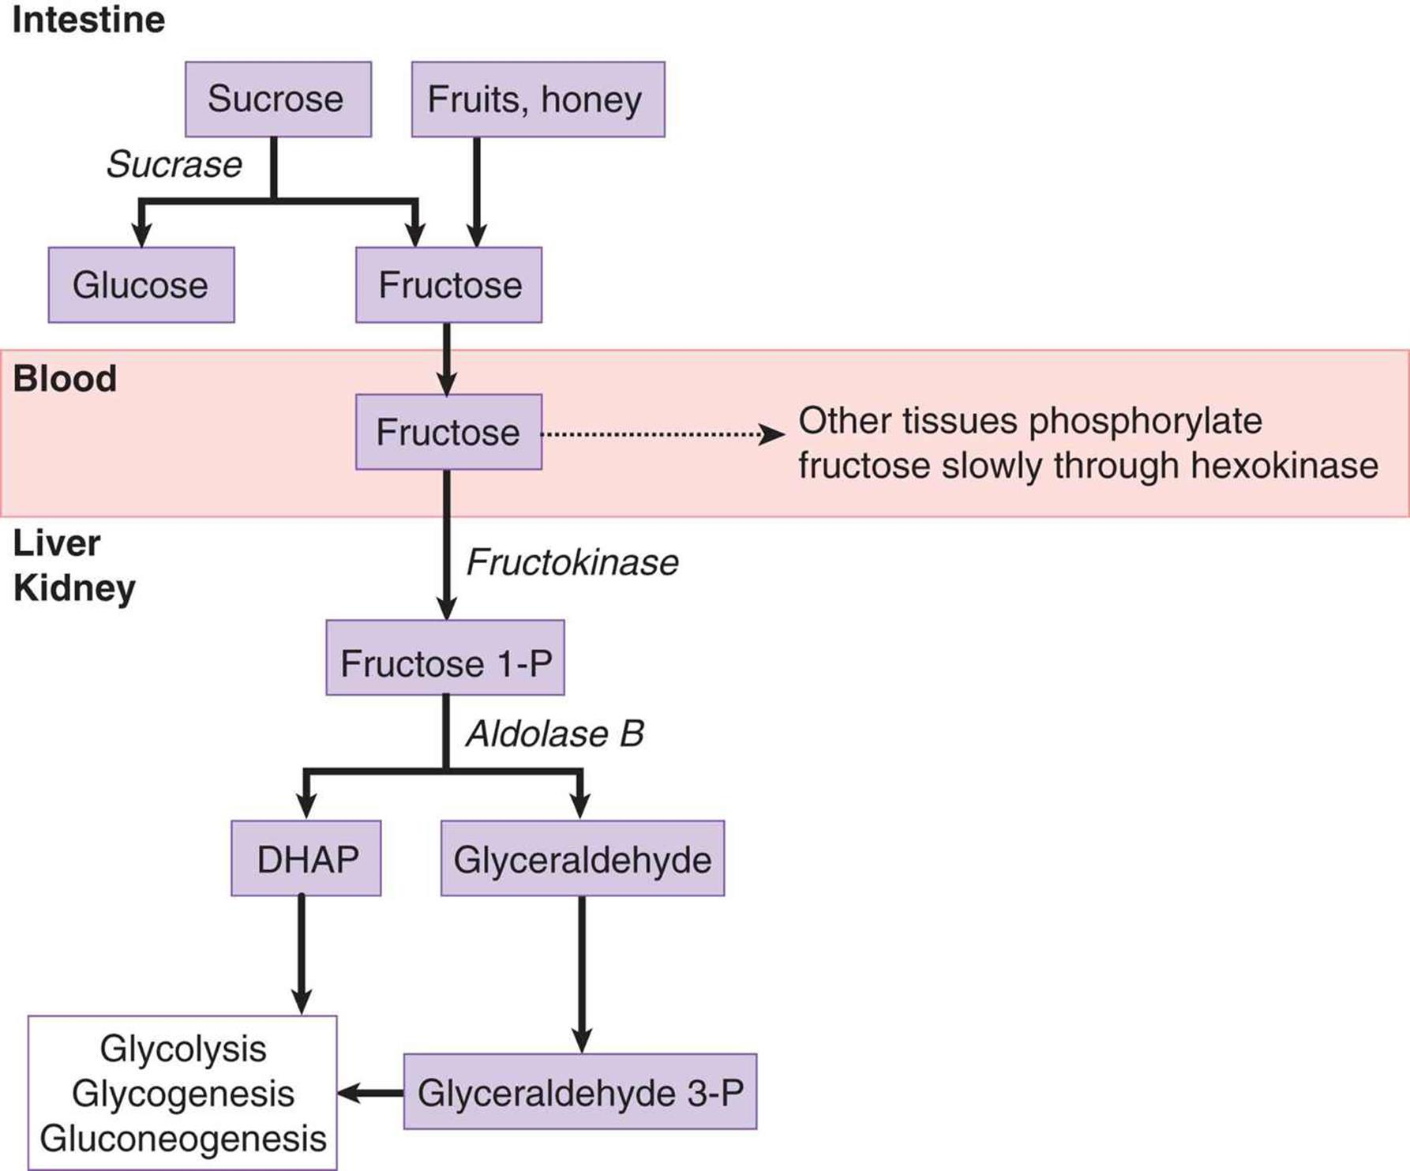

**9.4 Pyruvate Dehydrogenase**

* Refers to a complex of enzymes that convert pyruvate to acetyl-CoA
* Stimulated by insulin and inhibited by acetyl-CoA

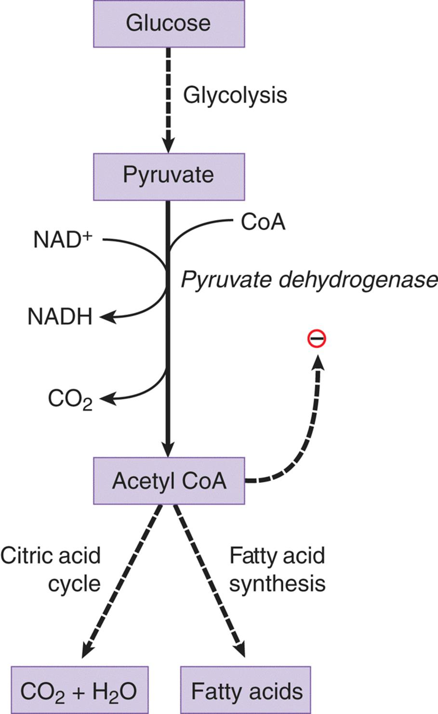

**9.5 Glycogenesis and Glycogenolysis**

* Glycogen = storage form of glucose

Glycogenesis (Glycogen synthesis)

* The production of glycogen using two main enzymes:
  + Glycogen synthase
    - Creates α-1,4 glycosidic links between glucose molecules
    - Activated by G6P and insulin
    - Inhibited by epinephrine and glucagon (through a protein kinase cascade)
  + Branching enzyme
    - Moves a block of oligoglucose from one chain and adds it to the growing glycogen using an α-1,6 glycosidic link

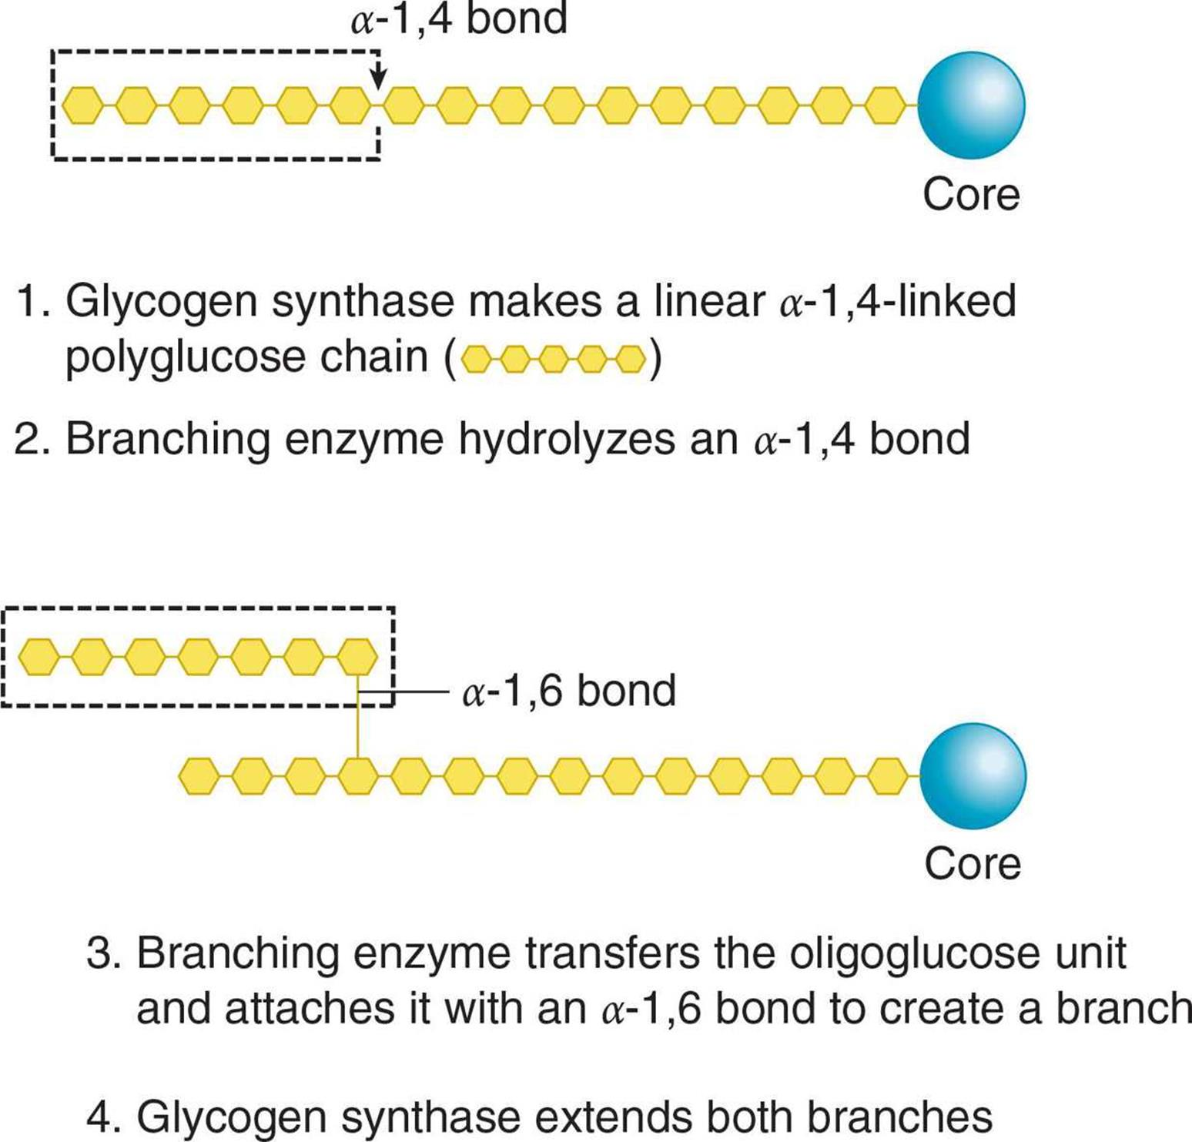

Glycogenolysis

* The breakdown of glycogen using two main enzymes:
  + Glycogen phosphorylase
    - Removes single G1P molecules by breaking α-1,4 glycosidic links
    - In the liver, it is activated by glucagon to prevent low blood sugar
    - In exercising skeletal muscle, it is activated by epinephrine and AMP to provide glucose for the muscle itself
  + Debranching enzyme
    - Moves a block of oligoglucose from one branch and connects it to the chain using an α-1,4 glycosidic link
    - Also removes the branchpoint, which is connected via an α-1,6 glycosidic link, releasing a free glucose molecule

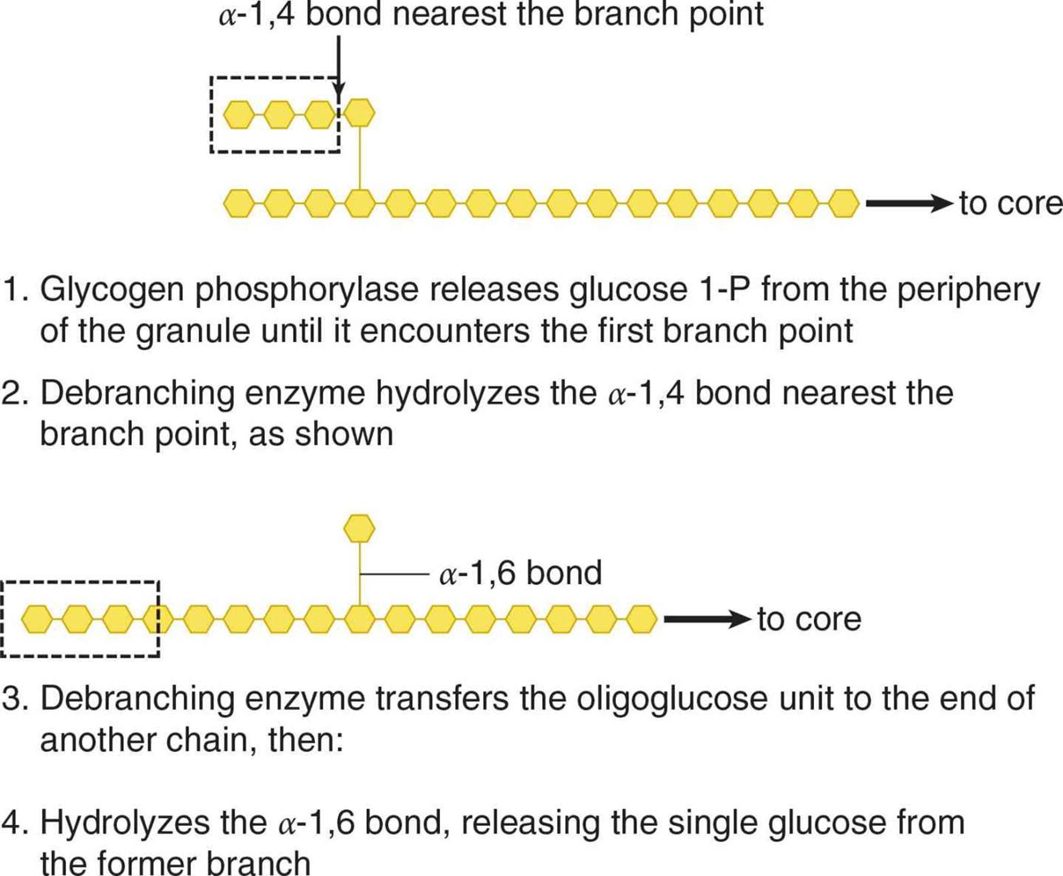

Glycogen Storage Disease

* Characterized by accumulation or lack of glycogen in one or more tissues
* Depends on:
  + Which enzyme is affected
  + The degree to which that enzyme’s activity is decreased
  + Which isoform of the enzyme is affected

**9.6 Gluconeogenesis**

* Occurs in both the cytoplasm and mitochondria, predominantly in the liver (with small contributions from the kidney)
* Occurs when an individual has been fasting for > 12 hours
  + To carry out gluconeogenesis, hepatic (and renal) cells must have enough energy to drive the process of glucose creation, which requires sufficient fat stores to undergo β-oxidation

Important Enzymes of Gluconeogenesis

* Most of gluconeogenesis is simply the **reverse of glycolysis**, using the same enzymes
* The three **irreversible** steps of glycolysis must be bypassed by different enzymes

|  |  |
| --- | --- |
| **Gluconeogenic Enzyme** | **Replaces** |
| Pyruvate carboxylase | Pyruvate kinase |
| Phosphoenolpyruvate carboxykinase (PEPCK) | Pyruvate kinase |
| Fructose-1,6-bisphosphatase | PFK-1 |
| Glucose-6-phosphatase | Glucokinase-I |

More details:

1. Pyruvate carboxylase and PEPCK
   1. Take note of precursors: lactate, amino acids, OAA (α-Ketoglutarate or any downstream molecule until OAA)

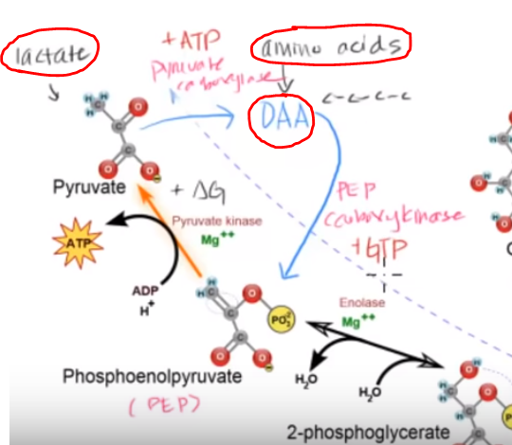

1. Fructose-1,6-bisphosphatase
   1. ATP coupling is not required

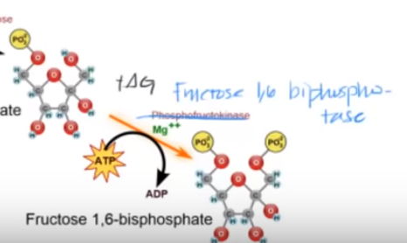

1. Glucose-6-phosphatase
   1. Without this enzyme, glucose cannot be formed through **gluconeogenesis** as well as **glycogenolysis** (breaking down of glycogen)
   2. Leads to hypoglycemia, which is life-threatening

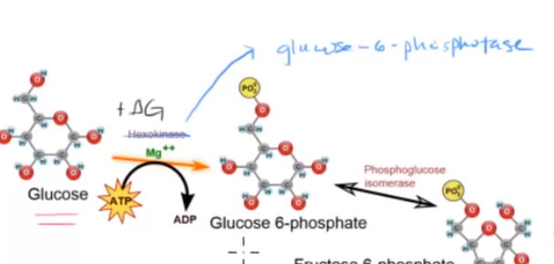

Glucogenic precursors

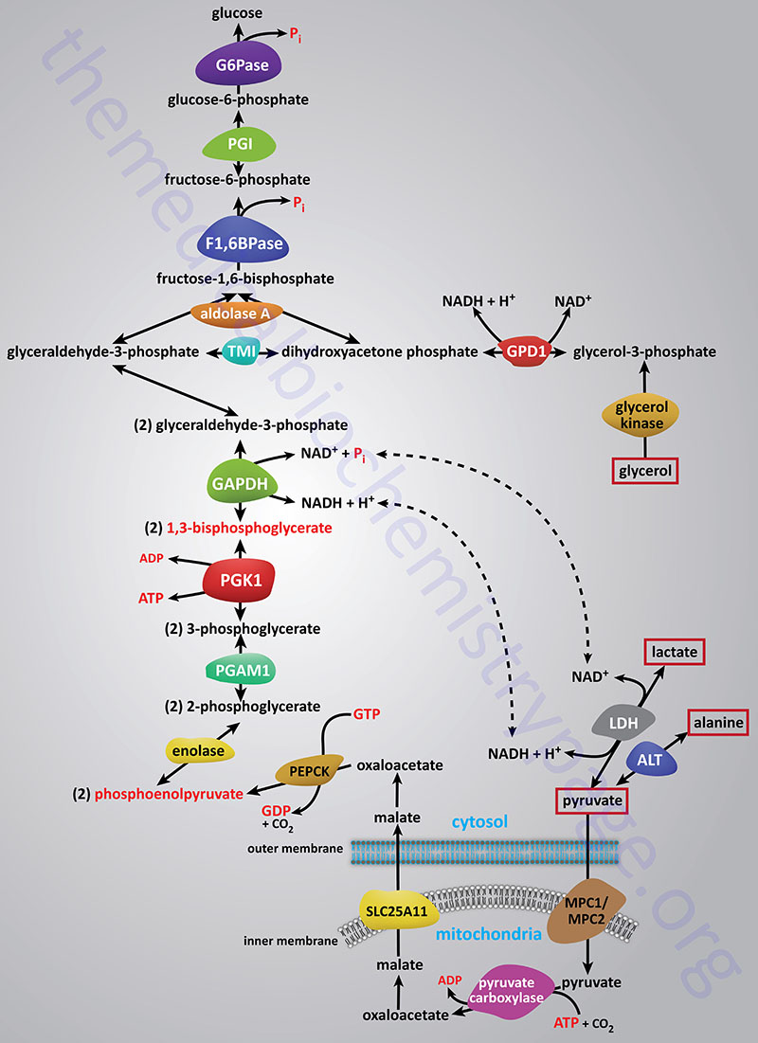

Role of Acetyl-CoA

* Inhibits pyruvate dehydrogenase complex while activating pyruvate carboxylase
* Net effect: burning pyruvate in the citric acid cycle → creating new glucose molecules for the rest of the body
* The acetyl-CoA from this regulation comes predominantly from β-oxidation, not glycolysis

**9.7 The Pentose Phosphate Pathway**

* Also known as the **hexose monophosphate (HMP)** shunt
* Occurs in the cytoplasm of most cells, generating:
  + NADPH
  + Sugars for biosynthesis (derived from ribulose-5-phosphate)
* Rate-limiting enzyme is G6PD, which is activated by NADP+ and insulin, and inhibited by NADPH

Functions of NADPH(mainly serve as a reducing agent)

* Biosynthesis, mainly of fatty acids and cholesterol
* Assisting in cellular bleach production in certain white blood cells, thereby contributing to to bactericidal activity
* Maintenance of a supply of reduced glutathione to protect against reactive oxygen species (acting as the body’s natural antioxidant)

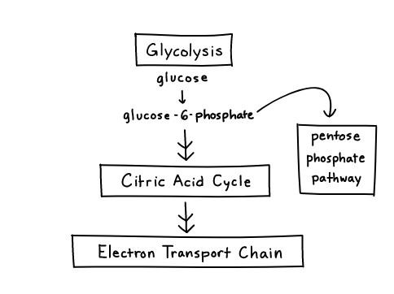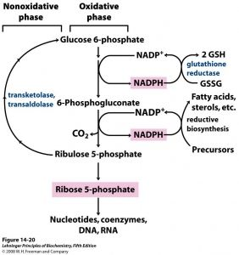

**9.8 Rate Limiting Enzymes for each process**

1. Glycolysis: phosphofructokinase-I (PFK-1)
2. Fermentation: lactate dehydrogenase
3. Glycogenesis: glycogen synthase
4. Glycogenolysis: glycogen phosphorylase
5. Gluconeogenesis: fructose-1,6-bisphosphatase
6. Pentose Phosphate Pathway: glucose-6-phosphate dehydrogenase (G6PD)